The Great Computer Challenge, 2023
Object-Oriented Business Programming,
Level 4

Background
Roman Numeral Calculator
The Romans were noted for many significant advances in math, the sciences and fine arts. The numbering system they developed used Roman Numerals to common numeric values. The values of the Roman digits are as follows:
I 1
V 5
X 10
L 50
C 100
D 500
M 1,000

Guidelines and Requirements
Demonstrate how to write a program and create a graphical user interface that is functional and interactive.

Challenge:
Design an applet that will allow the user to perform calculations on Roman Numerals. The arithmetic operators that your program should incorporate include: +, -, *, and /.
EXAMPLE:
- The number MCCXXVI is entered.

JAVA (50 points)
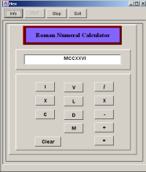
b. The “plus” sign is pressed.
c. The second number LXIX is entered.
d. The “equal” sign is pressed.
e. The following is the output generated
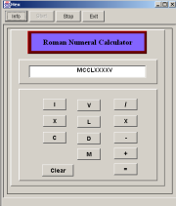

Judging Criteria
The code is executable, and it runs and creates an attractive output with all the requirements.

JAVA (50 points)

Have fun and thanks for participating in the
Great Computer Challenge, 2023!

