The Great Computer Challenge, 2021
Desktop Publishing, Level 4

Background

Your school is creating a community garden that reflects and celebrates the diversity of the student body and of the larger community. The garden will provide an opportunity for students to work together, learn together and eventually share the beauty and bounty with their neighbors.
Students will explore nature, practice teamwork, build leadership skills and learn to appreciate the differences and abilities we all have within us.
Your mission is to let the community know about the garden and invite them to a grand opening celebration. You will design an invitation to the event, create a sign that welcomes visitors, and produce a plantable seed card that guests can take home. Keep in mind the overall theme of diversity, which can be demonstrated by different types of vegetation and the people who cultivate them.

Guidelines & Requirements

Create three separate pieces (outlined in the “Challenge” sections below) to prepare for and invite the community to the opening of your school’s new Diversity Garden. Present all relevant information in a way that is easy to understand and visually interesting.
Be creative, creating a common theme and appearance (logos, colors, fonts) for all requirements, keeping your audience in mind. You may use scanned images, graphics, clip art, text, watermarks, and different font faces and sizes to enhance the piece.

Challenge 1
Invitation/Flier

For this challenge, you will create a flier inviting students, parents, teachers and neighbors to the opening of your school’s new diversity garden. It should be eye-catching and should invite the public to participate in the event and stay connected to the garden throughout the year. Have fun incorporating images and text that convey diversity and growth.

Format: | - 8.5 x 11” one-sided  - Vertical layout  - Full color
Include: | - Date & Time:  Saturday, May 15  10:00 a.m. to noon  - Location:  Your Great School  123 Garden Way
Activities | - Games, face painting, farmer’s market, food trucks

Challenge 2
Garden Sign

Design a sign that will be displayed at the garden entrance. The sign should be warm and welcoming, inviting people to enter and enjoy all the diversity garden has to offer: Education, Relaxation, Imagination, Cultivation, etc. (This can be done either through words or through imagery.)

Format: | 17 x 11”  Horizontal layout  Full color
Include: | - The name of your garden (you can call it Diversity Garden or come up with your own creative name)  - Artwork that resembles the theme of your invitation (from Challenge 1)  - Space for sponsor logos (you can use logos of real companies or just include placeholder blocks)

Challenge 3
Plantable Seed Card

These cards will be printed on special paper that contains wildflower seeds that guests can plant at home. They will be given to guests at the conclusion of the grand opening event as a thank-you for attending.

Format: | Horizontal or vertical layout  4 x 6” front and back  Full color
Front includes: | A dominant image on the front of the card  Example:  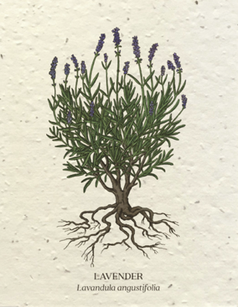
Back includes: | The name of your garden + address  Instructions for planting the card  - Cover in 1/8” soil  - Water daily until sprouts emerge  - Plant in full or partial sunlight  Example:  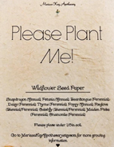

Judging Criteria

The solutions will be judged on the overall quality of layout and design with emphasis placed on thematic unity (how well all the items on the pages are related to the theme) and stylistic unity (a consistent “look and feel” to all parts of the solution).
Important: Judges will not necessarily have access to the software and fonts you use to create your work. When you are finished designing your pieces:
- Save your final design as a PDF or image file (JPG or PNG).
- Upload the PDF or image to your team’s Google Drive folder.
- You should have three (3) final files, one for each challenge.

SOL Correlation

Apply knowledge and skills to generate innovative ideas, products, processes, and solutions.
- Use various creative software, programming environments, or digital tools to convey existing ideas in new and effective ways.
- Use technology to develop innovative and effective solutions for assignments.

Have fun and thanks for participating in the Great Computer Challenge, 2021!

