The Great Computer Challenge, 2020
Desktop Publishing, Level 4

Scenario
Your school, Monarch High, is partnering with stopbullying.gov to implement an anti-bullying campaign during the month of May. The campaign’s purpose is to help identify bullying behavior and its effects, and to encourage students to be superheroes by standing up for others. Posters will be placed around your school encouraging students to participate in the campaign, and a temporary pop-up store will be set up to raise money for stopbullying.gov’s efforts to help prevent bullying of all kinds.
Your mission is to come up with a campaign slogan and design three cohesive printed pieces for this campaign, with an overall theme of superheroes. You’ll design a poster to raise awareness for the campaign, a postcard that can be mailed to “superheroes,” and a list of items available in the pop-up shop.

Guidelines & Requirements
Create three separate pieces (outlined in the “Challenge” sections below) to spread the anti-bullying superhero message throughout your school. Present all relevant information in a way that is easy to understand and visually interesting.
Be creative, creating a common theme and appearance (logos, colors, fonts) for all requirements, keeping your audience in mind. You may use scanned images, graphics, clip art, text, watermarks, and different font faces and sizes to enhance the piece.

Challenge 1 Campaign Poster
For this challenge, you will create a positive propaganda poster for the new anti-bullying campaign at your school. It should catch the attention of anyone who wants to participate in the campaign as well as spread a message of prevention and communication. Have fun incorporating your superhero mascot or slogan as well as your campaign colors and brand.
Format:
- 11x17” one-sided
- Horizontal or vertical layout
- Full color
Include:
- Campaign slogan / superhero theme
- Contact information for your school’s counseling office (or an anti-bullying hotline for students to report bullying behavior)
- Bullying prevention tips (how to recognize bullying behavior, what to do if you encounter a bully, how to stand up to a bully, etc.) Here are some tips from stopbullying.gov to get you started, or come up with your own!
  - Question the bullying behavior. Simple things like changing the subject or questioning the behavior can shift the focus.
  - Use humor to say something funny and redirect the conversation.
  - There is strength in numbers too! Bystanders can intervene as a group to show there are several people who don’t agree with the bullying.
  - Walk with the person who is the target of bullying to help diffuse potential bullying interactions.
  - Reach out privately to check in with the person who was bullied to let them know you do not agree with it and that you care. It makes a difference.

Challenge 2 “You’re My Hero” Postcard
As part of the campaign, all students will receive a free postcard they can mail to their own personal hero — someone who stands for what is right or has been a positive influence in their lives.

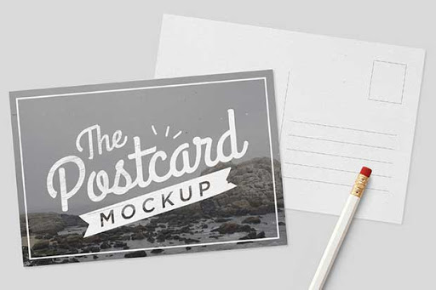
Format:
- 3.5x5” two-sided
- Full color
Front includes:
- “You’re My Hero” text (or similar)
- Your campaign slogan and superhero theme
Standard postcard back includes:
- Space for personal message
- Text area for address
- Area for postage stamp

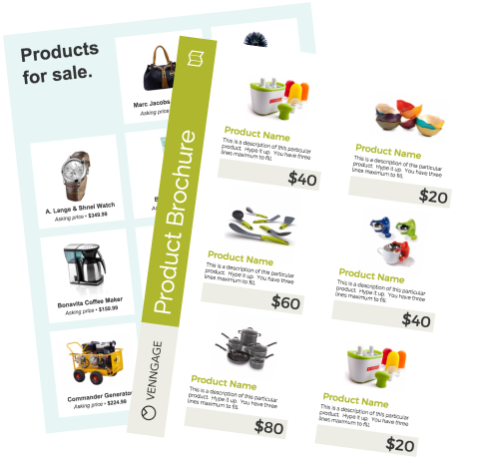
Challenge 3 One-Page Catalog
There will be a temporary pop-up shop in the cafeteria where students can purchase hero-themed items. Proceeds support stopbullying.gov. Create a one-page flier that serves as a catalog of the merchandise students can purchase. Design space for at least three separate items (examples: t-shirt, lanyard, pencils, stickers).
Note: This challenge will be judged on page layout, not content. You can be as detailed and creative with your product descriptions and artwork as you like, but if you’re running short on time, well-labeled placeholder blocks are fine.
Format:
- 8.5 x 11” one-sided
- Full color
Include:
- A heading and opening paragraph identifying this selection of products as part of your anti-bullying campaign
- Your campaign slogan, colors and theme (to coordinate with the other two pieces)
- Space for at least three separate items with prices

Judging Criteria
The solutions will be judged on the overall quality of layout and design with emphasis placed on thematic unity (how well all the items on the pages are related to the theme) and stylistic unity (a consistent “look and feel” to all parts of the solution).
Judges will refer to images on the computer monitor when evaluating final pieces. Contestants must leave filenames for the judges as well as instructions for accessing each file.

SOL Correlation
Apply knowledge and skills to generate innovative ideas, products, processes, and solutions.
- Use various creative software, programming environments, or digital tools to convey existing ideas in new and effective ways.
- Use technology to develop innovative and effective solutions for assignments.

Have fun and thanks for participating in the
Great Computer Challenge, 2020!

