The Great Computer Challenge, 2019
Desktop Publishing, Level II

Background
One in nine people do not have access to safe water

WATER FOR LIFE
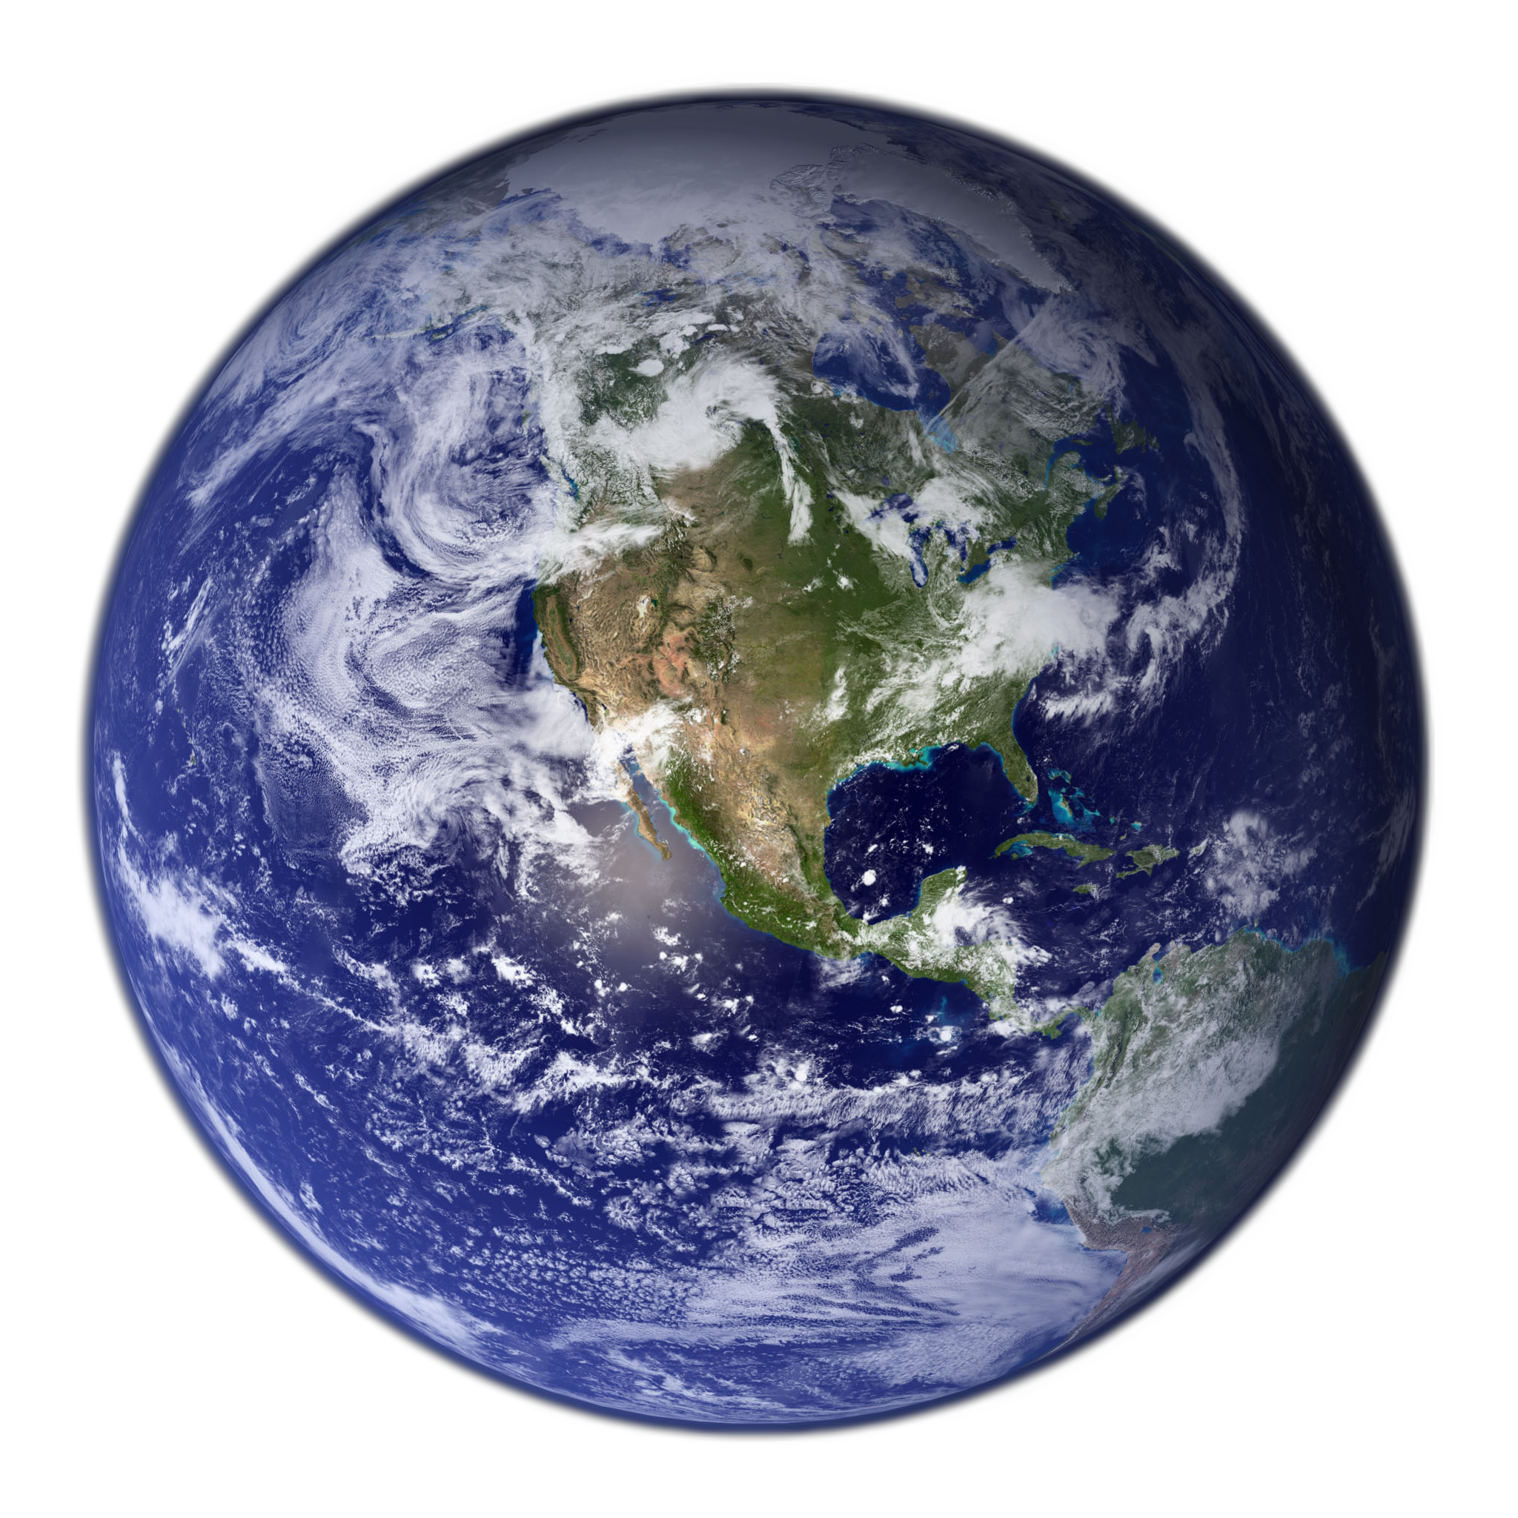 | 70% of the earth is water  3% is fresh water |  | 65% of your body is water  1% of fresh water is drinkable
Water regulates the Earth’s temperature and the temperature of your body. It is difficult to live more than three days without water.
WATER FOR PRODUCTS
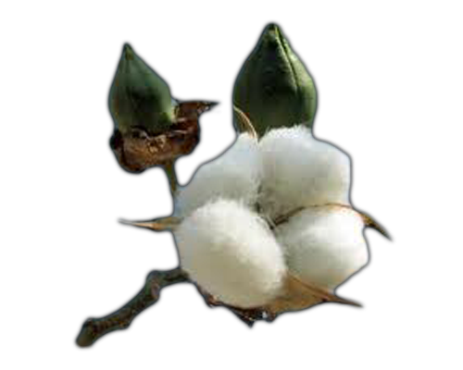 | 70% of fresh water is used for agriculture  2,700 liters of water to make a cotton T-shirt |  | 3 liters of water to make a 1 liter water bottle  1,000 years for that bottle to biodegrade
Water may be a renewable resource but human needs and activities make water limited. What can you do to save water?

Guidelines & Requirements
Desktop publishing uses software to organize information and create documents. Your team will be judged on your message, layout, and details of your work.

Challenge 1
Create a poster to help your classmates learn how to save water:
- Include a main message and at least three ways to save water at school and/or home
- Use space, graphics, and color to draw attention to your information
- Be accurate and original to catch and keep the reader’s attention

Challenge 2
Design a sticker to pass out to friends and family to promote your message about the importance of saving water.

Judging Criteria

RUBRIC | 5 (25 points) | 4 (20 points) | 3 (15 points) | 2 (10 Points) | 1 (5 points)
Message/ Information | Provides clear message and excellent information on topic | Provides related message and good information on topic | Provides satisfactory message and sufficient information | Provides unclear message and little information | Provides unrelated message and  off topic information
Organization/  Layout | Is well organized and appealing to the eye, pleasure to read | Is organized and arranged logically, balanced and easy to read | Has some organization, unbalanced layout but readable | Has little organization, layout difficult to read | Has confusing organization and layout, do not want to read
Spelling/  Grammar | Contains no spelling or grammar errors | Contains one spelling or grammar error | Contains two spelling or grammar errors | Contains three spelling or grammar errors | Contains many spelling or grammar errors
Creativity/  Detail | Incorporates imaginative elements and artistic detail | Incorporates relevant elements and important detail | Incorporates average elements and some detail | Incorporates distracting graphic elements, insufficient detail | Incorporates no elements and poor attention to detail

SOL Correlation
- K7. Basic needs for life
- 1.8 Natural resources are limited
- 2.5 Living things as part of a system
- 3.9 Importance of water cycle for plant and animal life
- 4.9 Virginia natural resources- plants, animals, watersheds, water resources, minerals, rocks
- 5.6 Ocean environment

Have fun and thanks for participating in the Great Computer Challenge 2019!

