The Great Computer Challenge, 2023
Desktop Publishing, Level 4

Background
Monarch High School’s basketball team is going to States! The hallways are buzzing with excitement and the entire community is rallying to support this team with various fund-raising events to help cover the costs of team transportation and new gear. The school plans to help raise money in a few different ways:
• Limited edition merchandise sold in the school store
• A faculty/student basketball game
• A good old fashioned car wash
Your mission is to come up with three printed pieces that spark school spirit and spread enthusiasm for the upcoming championship and the various fund-raising opportunities. You’ll design a poster to announce a car wash, a ticket for admission to the faculty/student basketball game, and a catalog of items available for sale in the school store.

Guidelines & Requirements
Create three separate pieces (outlined in the “Challenge” sections below) to promote the team and their fund-raising efforts. Present all relevant information in a way that is easy to understand and visually interesting.
Be creative, creating a common theme and appearance (logos, colors, fonts) for all requirements, keeping your audience in mind. You may use scanned images, graphics, clip art, text, watermarks, and different font faces and sizes to enhance the piece.

Challenge 1 Poster
For this challenge, you will create a poster advertising a car wash to benefit Monarch High School’s basketball team on their road to States. The poster will be displayed around school, as well as in local businesses and around town. Anyone with a set of wheels is welcome to have their vehicle washed for a donation to the team.
Format:
- 11x17” one-sided
- Horizontal or vertical layout
- Full color
Include:
- The purpose of the car wash (to raise money for the team’s upcoming adventure)
- Date and time of car wash (any date will do)
- Location (you can make up an address)

Challenge 2 Game Ticket
The basketball team has challenged the faculty to a good-natured basketball game after school. Create a ticket for a faculty/student basketball game. Admission is $5, and all proceeds benefit the team’s trip to States.
Format:
- 3.5 x 8.5” one-sided
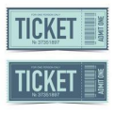
- Horizontal or vertical layout
- Full color
- Tear-off section (a part of the ticket that can be torn off at the door –
can be whatever size you choose)
Include:
- Name of event
- Game location, date and time
- Cost of ticket
- Lots of school spirit

Challenge 3 One-Page Catalog
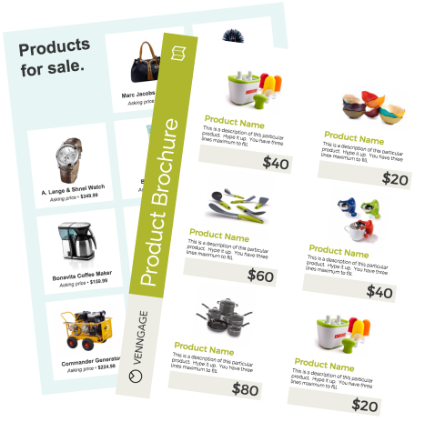
The school store will have limited edition merchandise for sale, including T-shirts,
stickers, pencils, etc. Proceeds benefit the team. Create a one-page flier that
serves as a catalog of the merchandise available for purchase. Design space for at
least three separate items.

Note: This challenge will be judged on page layout, not content. You can be as detailed and creative with your product descriptions and artwork as you like, but if you’re running short on time, well-labeled placeholder blocks are fine.
Format:
- 8.5 x 11” one-sided
- Full color
Include:
- A heading and opening paragraph identifying the purpose of the sale
- Colors and theme to coordinate with the other two pieces
- Space for at least three separate items with prices

Judging Criteria
The solutions will be judged on the overall quality of layout and design with emphasis placed on thematic unity (how well all the items on the pages are related to the theme) and stylistic unity (a consistent “look and feel” to all parts of the solution).

Have fun and thanks for participating in the
Great Computer Challenge, 2023!

