Great Computer Challenge 2023
Video Editing, Level 2

Background

You have been supplied with various video clips of farmers who are concerned about sea level rise and their crops. Review the footage provided and mentally log the video clips (crowds, interviews, etc) and create a one minute informative video. This video is meant to inform the public about the issues facing farmers and sea level rise. Today you have been provided with all of the essential video, music and interviews to create this informative piece.

Guidelines & Requirements
You must create a video that includes the following items:
- Make sure the video is understandable.
- Use music/voiceover (music provided on flash drive) in a way that helps the message of the video and does not distract from the purpose of the video. You may also record and use a voiceover, but a voiceover is not required.
- Use selected interviews (from the video B-Roll provided) that will enhance the overall purpose and message of the video.
- Graphics and Text – you are expected to use font (size, style, color) that will reinforce the message through words and images on the screen.
- Effects – use effects such as wipes, patterns, transitions, etc., thoughtfully to carry the viewer through the video (beginning to the middle to the conclusion) without distracting the viewer from the message of your video
- Spelling and Grammar – you are expected to use correct spelling and grammar to enhance and reinforce key words, ideas, and titles in your video
- No inclusion of any web accessed or downloaded music and visual effects can be used.
- No additional technical instruments outside of the editing program (i.e., iphone, Bluetooth, dongle devices, android, tablet, etc.) can be used.

Challenge 1
You must create a video that includes the following items:
1. Psychological continuity (make sure the video is understandable) and that your video has a smooth intro and close to be considered complete.
2. Incorporate music/voiceover that aides in the video excitement, transitions, etc (the music must enhance not compete with the overall promotional video). The music/voiceover will further enhance or heighten the segments within the video. No outside musical source can be used (internet, unauthorized music option such as a CD, MP3 download, etc) ***recording your own voiceover is not required, but can be used***
3. Incorporate interviews (from the video B-Roll provided) that will enhance the overall purpose of the promotional video
4. Graphics – you are expected to use font (size, style, color), spelling/grammar, etc., that will reinforce the message through words on the screen
5. Effects – this will include wipes, patterns, transitions, etc., that will carry the viewer throughout the video (beginning to the middle to the conclusion)
6. Spelling/Grammar – use of spelling/grammar to enhance and reinforce the video (key words/titles/etc) must be accurately demonstrated and implemented
7. No inclusion of any web accessed or downloaded music and visual effects outside of the editing program.
8. No additional technical instruments outside of the editing program (i.e., iPhone, Bluetooth, dongle devices, android, tablet, etc) can be used.
9. When finished you must save your project to the desktop and leave open for judging. If there is a password associated with getting into the computer, please leave on a post-it and visible for the judge to access the project.

Judging Criteria

The overall evaluation of the final video will be based on the following items:
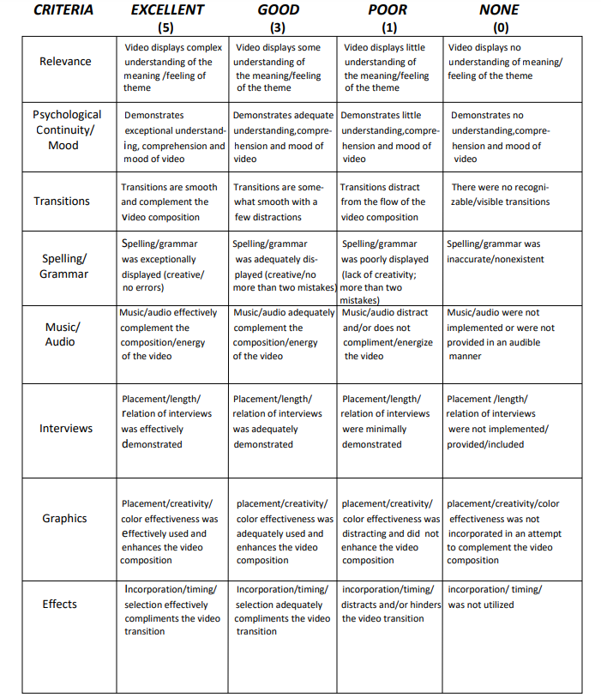
Have fun and thanks for participating in the
Great Computer Challenge 2023!

