The Great Computer Challenge, 2020
CAD, Level 4

Background
CAD technology is used in the design of tools and machinery and in the drafting and design of all types of buildings, from small residential types (houses) to the largest commercial and industrial structures (hospitals and factories).
The benefit of CAD systems over manual drafting are the capabilities one often takes for granted from computer systems today; automated generation of Bill of Material, auto layout in integrated circuits, interference checking, and many others. CAD was a revolutionary change in the engineering industry, where draftsmen, designers and engineering roles begin to merge. CAD is mainly used for detailed engineering of 3D models and/or 2D drawings of physical components, but it is also used throughout the engineering process from conceptual design and layout of products, through strength and dynamic analysis of assemblies to definition of manufacturing methods of components. It can also be used to design objects.
CAD has become an especially important technology within the scope of computer-aided technologies, with benefits such as lower product development costs and a greatly shortened design cycle. CAD enables designers to layout and develop work on screen, print it out and save it for future editing, saving time on their drawings.

Guidelines & Requirements
For each of the following 5 parts (do as many as you can in the allotted time) you will create two drawings:

A 3-D model.

- The necessary orthographic views with dimensions.

- Make reasonable assumptions for any missing dimensions or information.

- Insert a title block for each drawing and include all the information pertaining to your team and your school.

- Be sure to save your work and open all drawings when finished for judging. If you have a printer you may print them out for judging.

Challenge Part 1
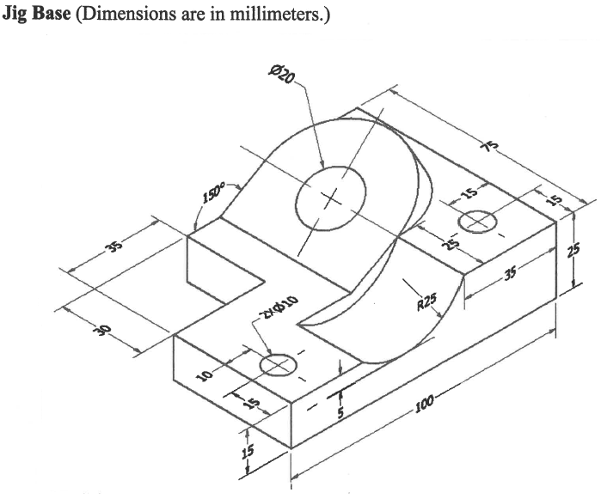

Challenge Part 2
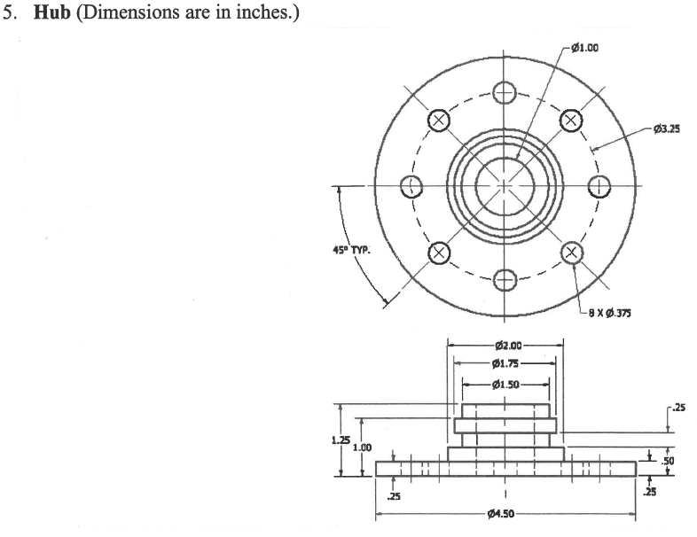

Challenge Part 3
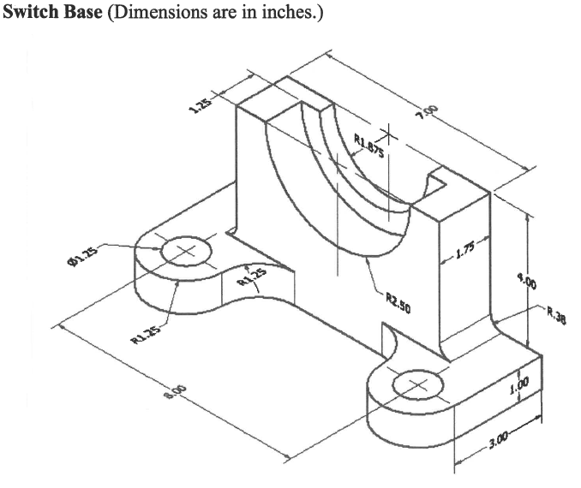

Challenge Part 4
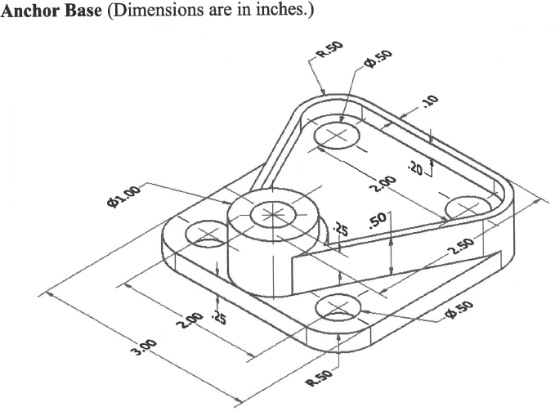

Challenge Part 5
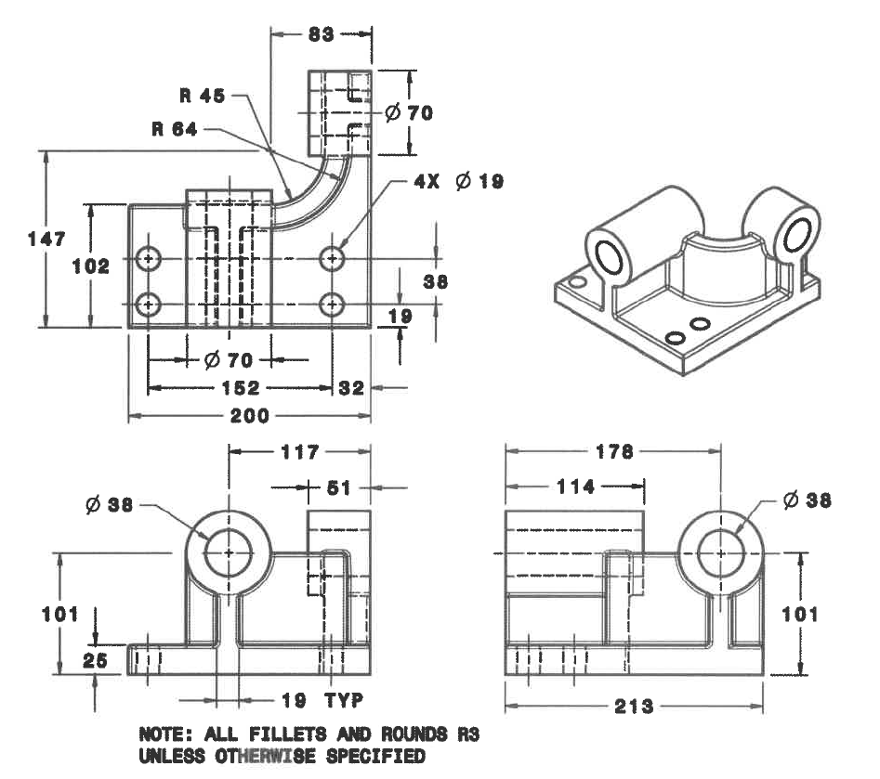

Judging Criteria

- Make reasonable assumptions for any missing dimensions or information.
- Insert a title block for each drawing and include all the information pertaining to your team and your school.
- Be sure to save your work and open all drawings when finished for judging. If you have a printer you may print them out for judging.
- Solutions will be evaluated on accuracy and completeness of the of the 3-D models along the proper application of orthographic projection and dimensioning rules

SOL Correlation

Apply knowledge and skills to generate innovative ideas, products, processes, and solutions.

- Use various creative software, programming environments, or digital tools to convey existing ideas in new and effective ways.
- Use technology to develop innovative and effective solutions for assignments.

Have fun and thanks for participating in the
Great Computer Challenge, 2020!

