The Great Computer Challenge, 2018
Desktop Publishing, Level IV

Background

With over 10,000 animals representing over 300 species, the Virginia Aquarium has an incredible amount of fun for anyone. The Virginia Beach location features hands-on exhibits, a nature path and marshlands to explore, as well as educational boat trips, documentaries and an eco-friendly adventure park.
In addition to exhibits, the Virginia Aquarium is committed to educating the public about the marine environment and inspiring conservation of wildlife and wild places. Their Stranding Response team provides aid to all marine mammals and sea turtles that come ashore in Virginia, and works with local children to create educational sea turtle sculptures out of trash items that are collected during cleanups. The water quality lab processes environmental samples from community volunteers and groups interested in monitoring local waterways, including storm water retention ponds, creeks, rivers, estuaries and other natural bodies of water. They work to restore local live coral species, provide an environment for sea turtles to grow and thrive, monitor frog and toad populations, and track osprey movement.
Your challenge today is to promote some of the featured exhibits at the Virginia Aquarium and put together some information about available summer camp options for children.

General information about the aquarium:
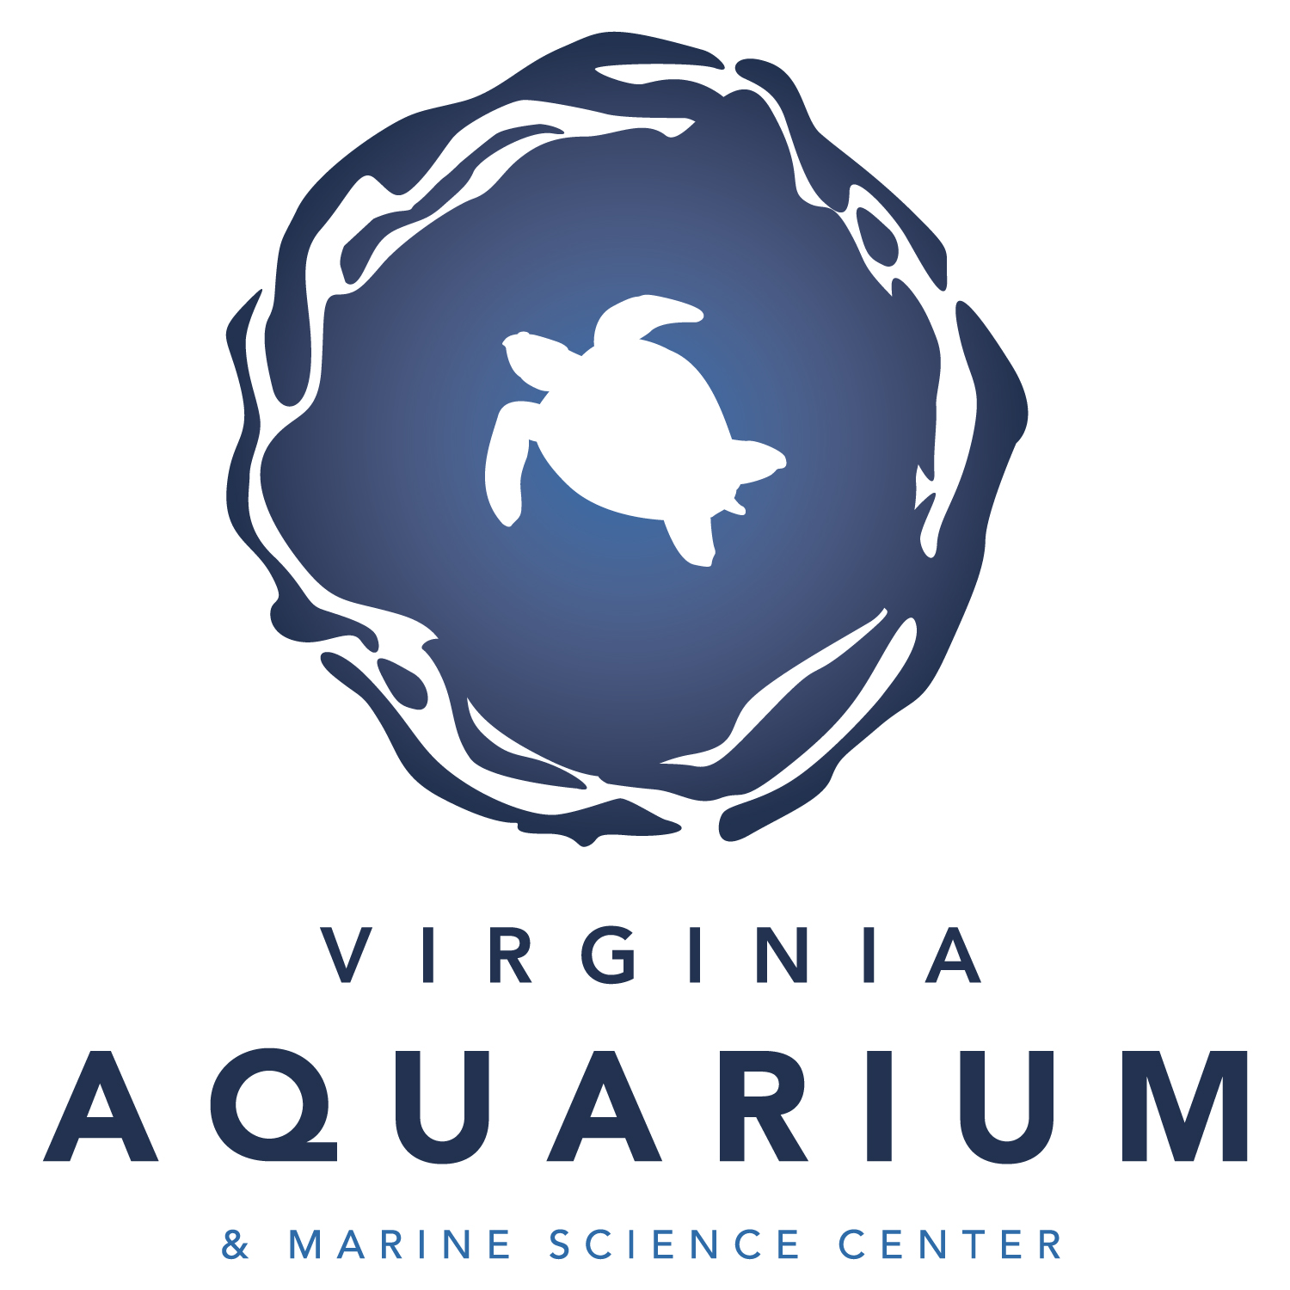
Virginia Aquarium & Marine Science Center
717 General Booth Blvd.
Virginia Beach, VA 23451
(757) 385-FISH
www.virginiaaquarium.com

Guidelines & Requirements

Create three separate pieces (outlined in the “Challenge” sections below) for the Virginia Aquarium. Present all relevant information in a way that is easy to understand and visually interesting.
Be creative, creating a common theme and appearance (logos, colors, fonts) for all requirements, keeping your audience in mind. You may use scanned images, graphics, clip art, text, watermarks, and different font faces and sizes to enhance the piece.

Challenge 1 Whales & Wildlife Flier

The Virginia Aquarium & Marine Science Center is doing Boat Trips over the summer to help kids learn about the wildlife in our area – up close and personal. They need to create a flier to advertise the “Whales & Wildlife” Boat Trip to students in your school.
Whales & Wildlife Description:
The Virginia Aquarium & Marine Science Center presents: Whales & Wildlife! This 2-2.5 hour trip in search of whales, dolphins, seals, and seabirds brings you as close as possible to commonly observed species like acrobatic humpback whales, fin whales, minke whales, critically endangered right whales, bottlenose dolphins, harbor porpoises, and harbor seals, as well as an immense variety of seabirds and waterfowl. Tickets are $28 for adults and $24 for kids.
Departure Times:
Wednesday | 2pm
Thursday | 2pm
Friday | 2pm
Saturday | 10am and 2pm
Sunday | 10am and 2pm

Requirements:
- An 8.5x11” Flier that includes:
  - Organization Name & Logo (or logo placeholder)
  - Event Name
  - Picture(s)
  - Trip Times
  - Ticket Prices

Challenge 2 Summer Camps Booklet

You will design a 4-page booklet inviting kids to the Summer Camps at the aquarium: Wonders of Water and Reptiles and Amphibians. The booklet should be something schools, teachers, parents, and kids could look at to find out more information and get excited about the camp.

Summer Camps Information:
For Ages 6-7 (All camps are two days, 9am to 1pm)

Wonders of Water
June 25-26; July 16-17
Search for aquatic animals, investigate watery habitats, and participate in hands-on explorations that reveal the magic of water and the adaptations needed to survive in it.
Fee: $60 members; $80 non-members

Reptiles and Amphibians
June28-29; July 19-20
Some are smooth and slimy while others are dry and scaly. Come discover who slithers, who hops, and who swims. Learn to identify amphibians and reptiles through observation, hands-on activities, and live animal encounters.
Fee: $60 members; $80 non-members

Requirements:
The format will be an 8.5x11” sheet of paper folded in half, to make four half-pages. The booklet should include:
- A cover including:
  - The aquarium’s name and logo
  - The subtitle: “Experience the Adventure of Summer Camp at the Aquarium”
- One page about the Wonders of Water camp
- One page about the Reptiles and Amphibians camp
- A back page that includes contact information and how to register for the camp.

Challenge 3 Registration Form

You will create a registration form for students interested in attending the Wonders of Water or Reptiles & Amphibians summer camps. Use the summer camps information to create a themed, cohesive document that will accompany the Summer Camps Booklet created in Challenge 2.

Requirements:
Please design a one page 8.5x11” registration form that includes:
- Aquarium theme
- Fields for the applicant to enter:
  - Name, birthdate, address
  - Parent Name, address and phone number
  - Place to select which camp and what dates they wish to attend
- Request payment delivered to the Aquarium by March 28 and to make checks payable to: Virginia Aquarium & Marine Science Center.
- Note that medical forms and emergency contact forms are due with payment.
- Note that cancellations must be made two weeks in advance of program for full refund. The Aquarium will notify you if a camp is filled or cancelled. For more information contact the Education Department at (757) 385-0278.

Judging Criteria

The solutions will be judged on the overall quality of layout and design with emphasis placed on thematic unity (how well all the items on the pages are related to the theme) and stylistic unity (a consistent “look and feel” to all parts of the solution).
Judges will refer to images on the computer monitor when evaluating final pieces. Contestants must leave filenames for the judges as well as instructions for accessing each file.

SOL Correlation

Apply knowledge and skills to generate innovative ideas, products, processes, and solutions.
- Use various creative software, programming environments, or digital tools to convey existing ideas in new and effective ways.
- Use technology to develop innovative and effective solutions for assignments.

Have fun and thanks for participating in the Great Computer Challenge, 2018!

