The Great Computer Challenge, 2018
Cyber Security, Level IV

INSTRUCTIONS FOR VIRTUALBOX INSTALLATION
Visit https://www.virtualbox.org/wiki/Downloads
Download Windows Host if you are running Windows; OS X if you are running MacOS.
Select next, next, next, yes, install, finish (All default options).
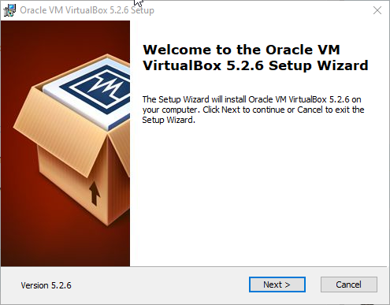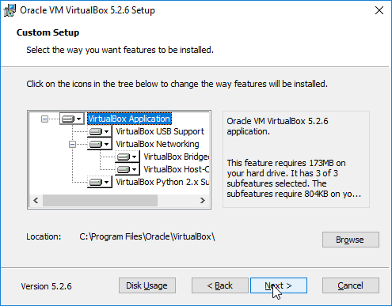
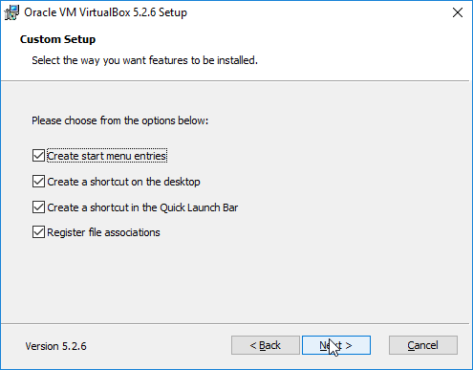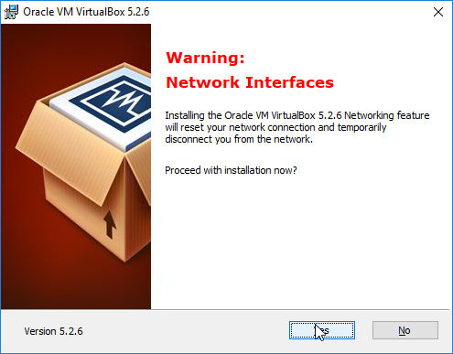
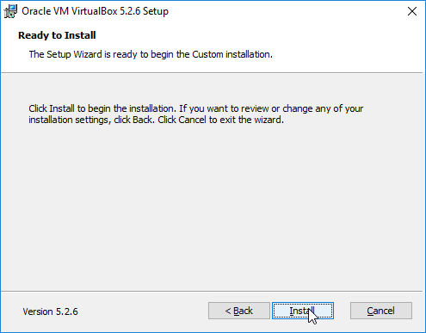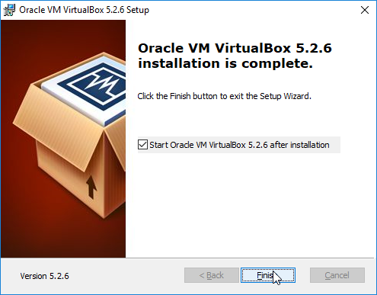

INSTRUCTIONS FOR KALI LINUX INSTALLATION
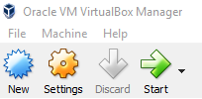
Click ‘New’
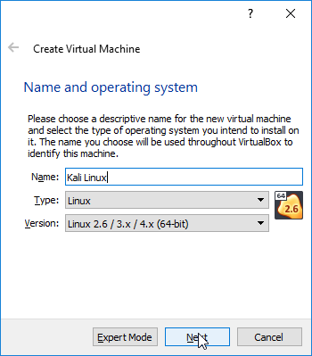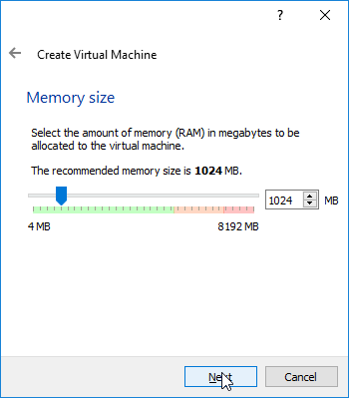
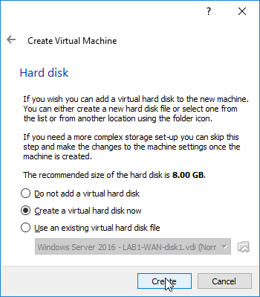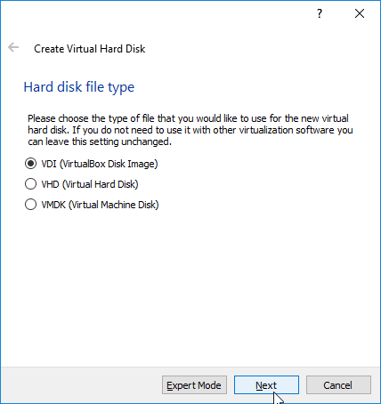

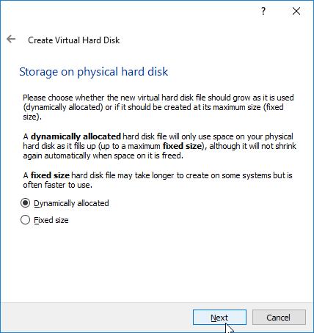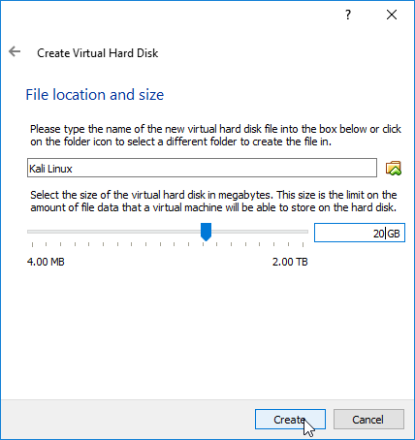
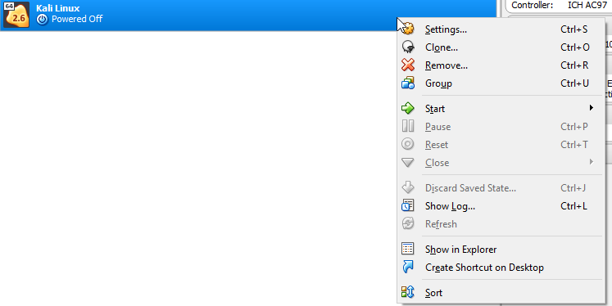
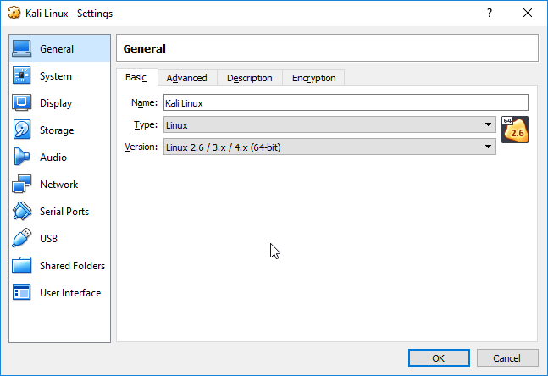
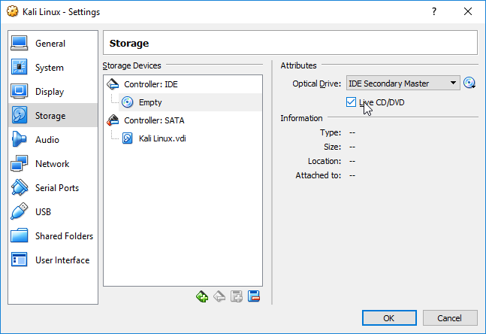
Check the Live CD/DVD Box; click the little CD.
Select your KALI ISO (Mine is kali-linux-2018.1-amd64.iso)
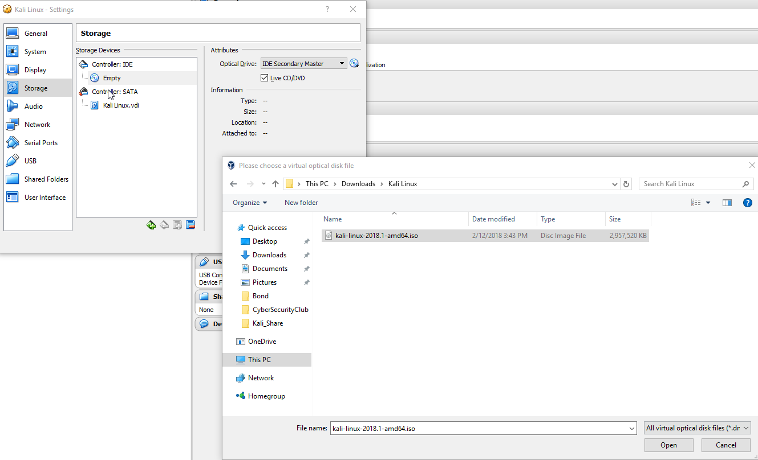
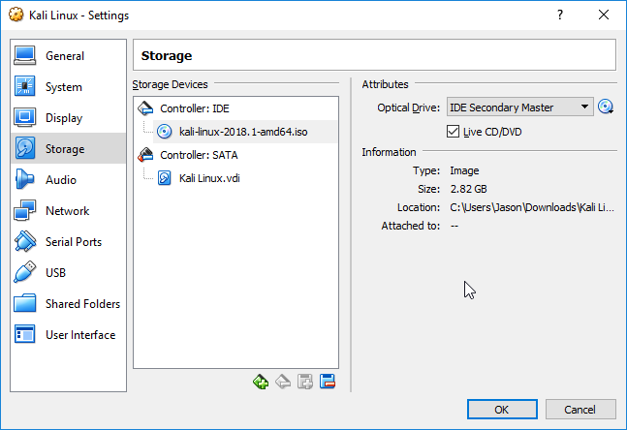
Start your virtual machine
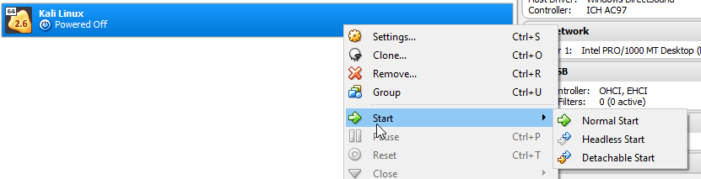
Click ‘Don’t show again’, then capture.
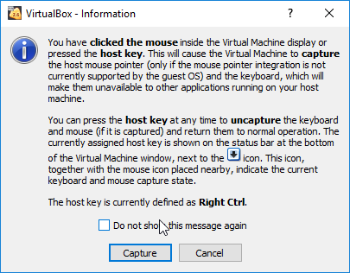

Start of the OS installation
Very straight forward
Select ‘Install’
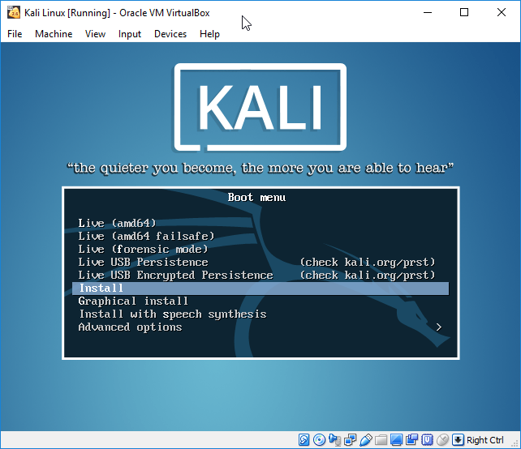

Select English, United States, and American English keyboard
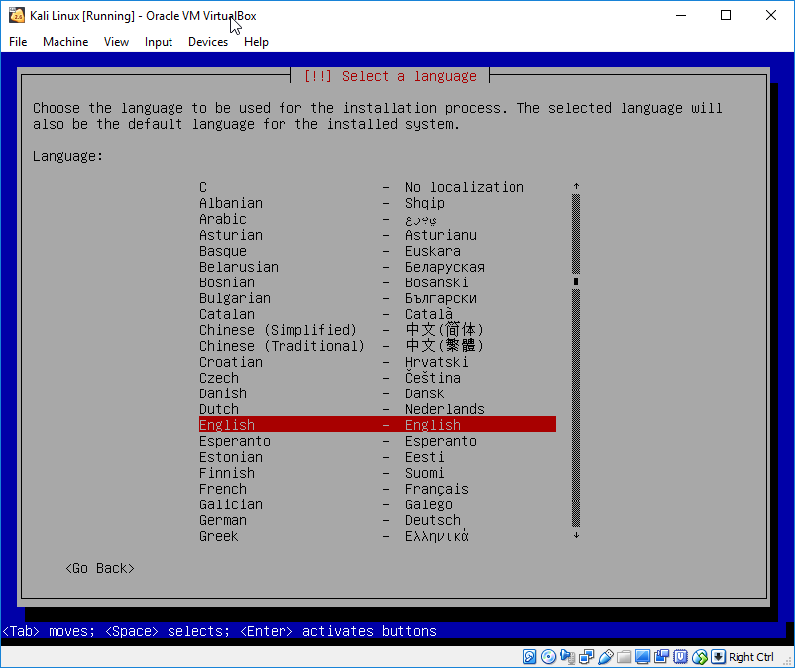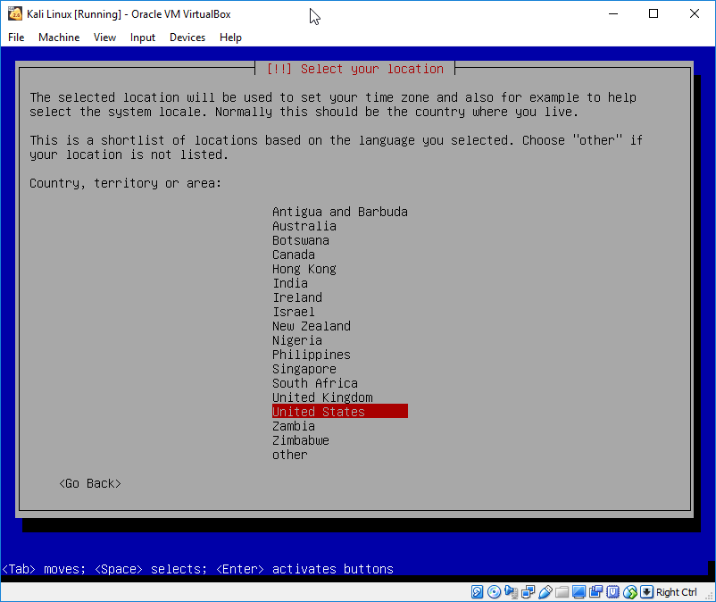
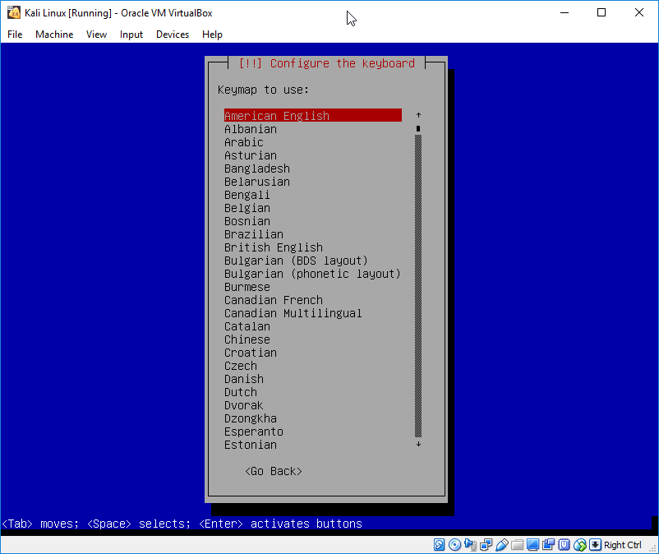

Set the name of the host, can keep as just default ‘kali’
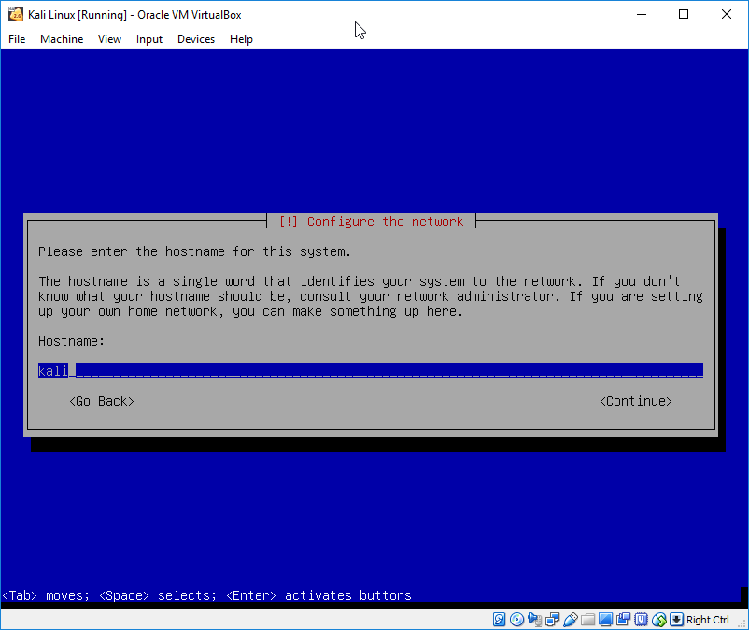
Leave domain name blank.
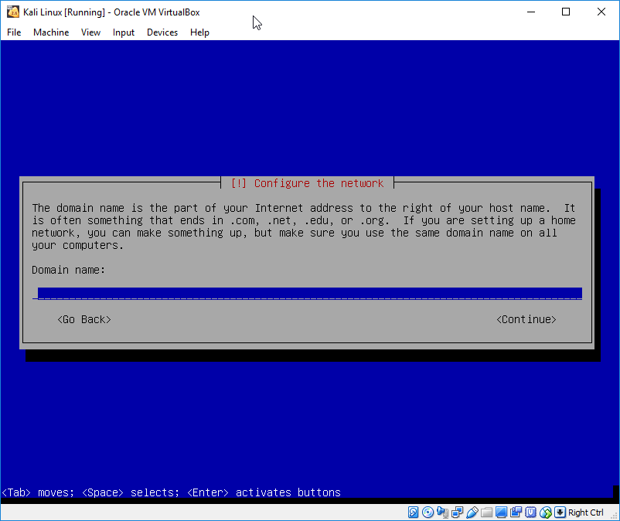

The username and password can be whatever you wish.
For simplicity purposes, I normally do
User: root
Pass: toor
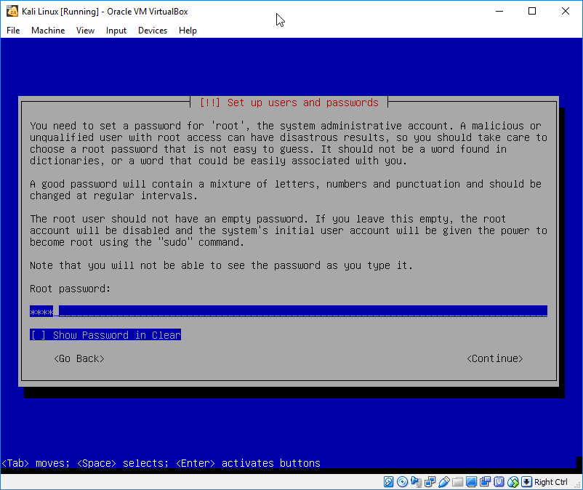
Time setting; Eastern time.
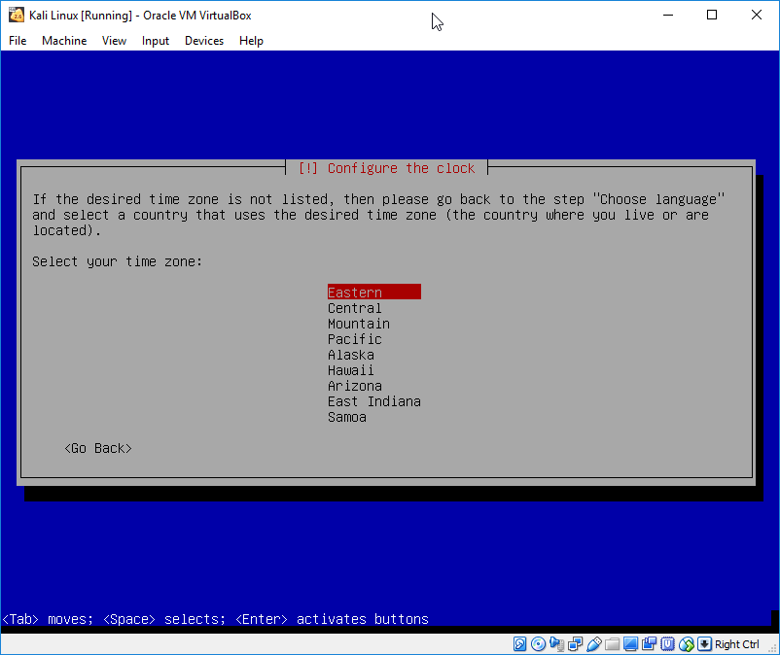

Selected ‘Guided – use entire disk’
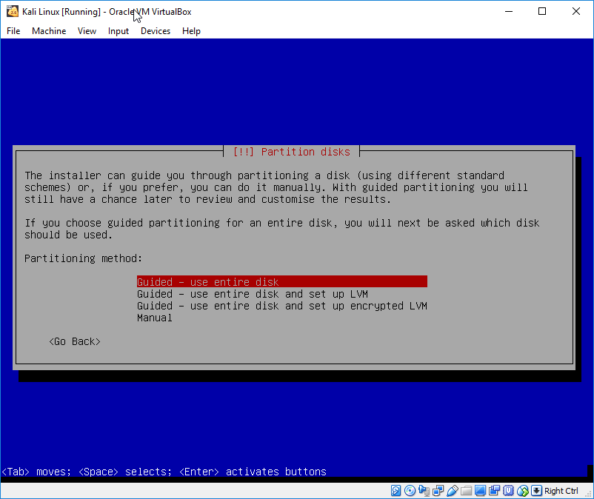
Select Disk to partition (only one)
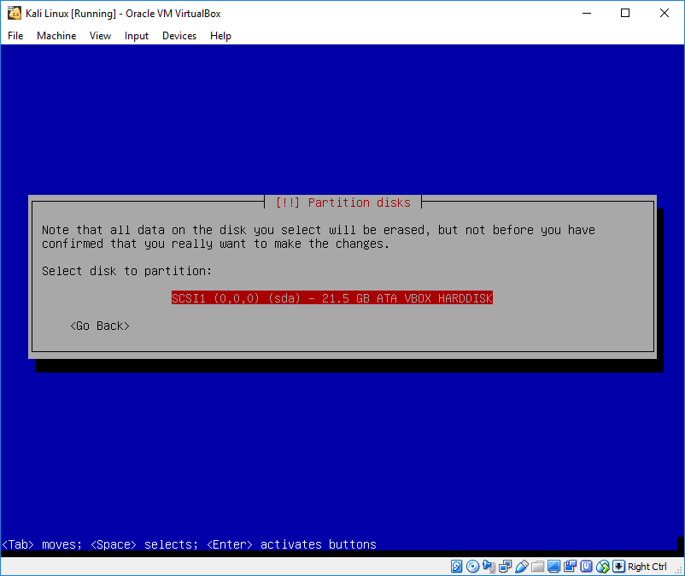

Choose the default partition option and easiest ‘All files in one partition’
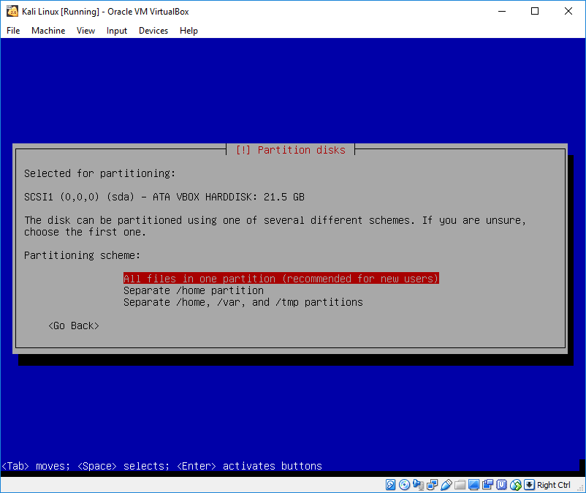
Select YES to write changes.
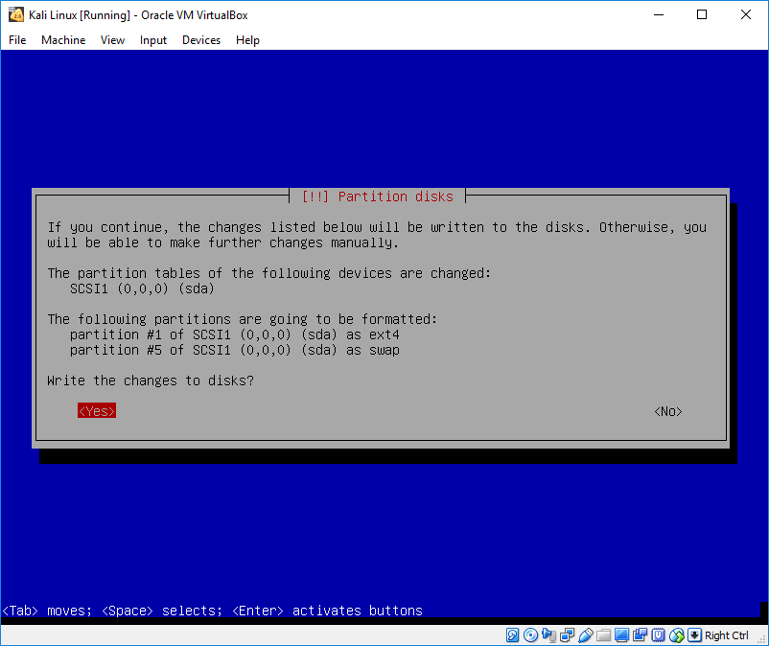

Now just wait, should take five minutes or so. 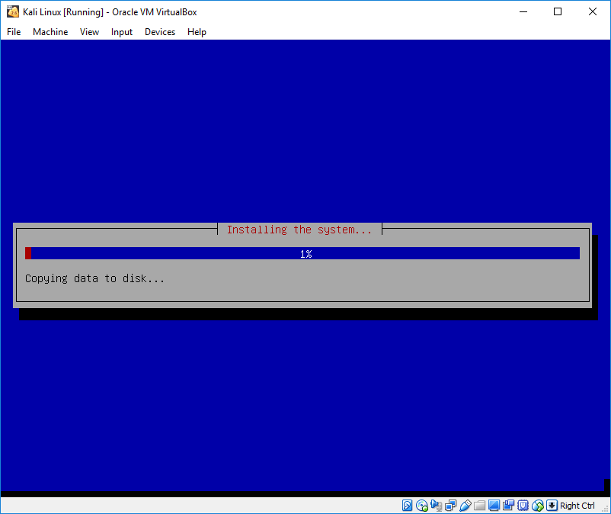

Select YES to network mirror, otherwise you will have future issues (can’t update KALI).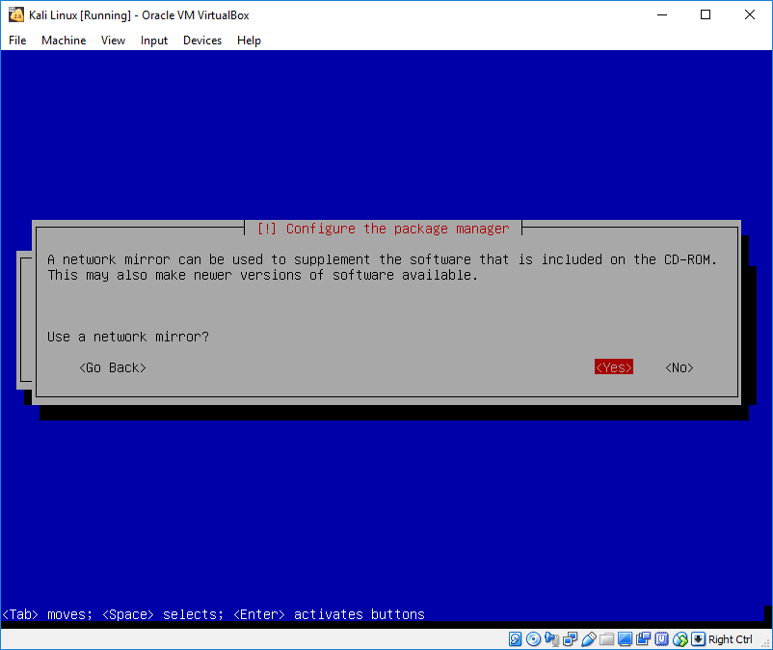
Select CONTINUE with NOTHING in the PROXY information line. 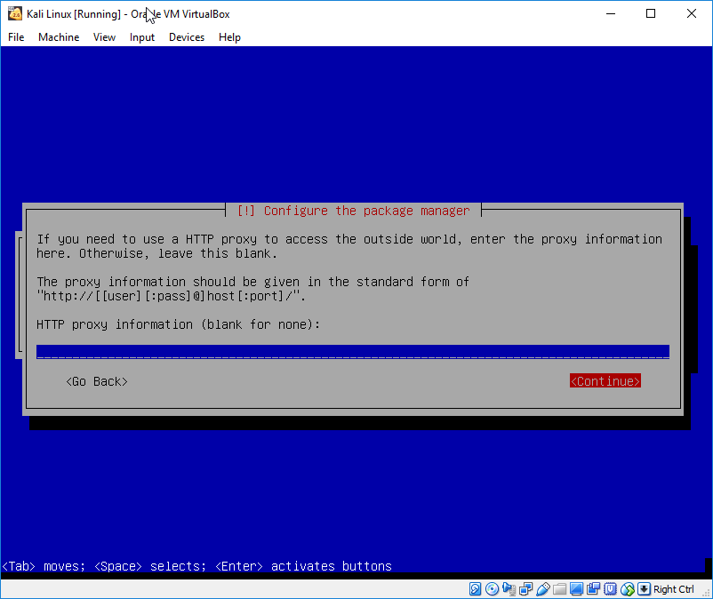
Select YES on GRUB boot loader.
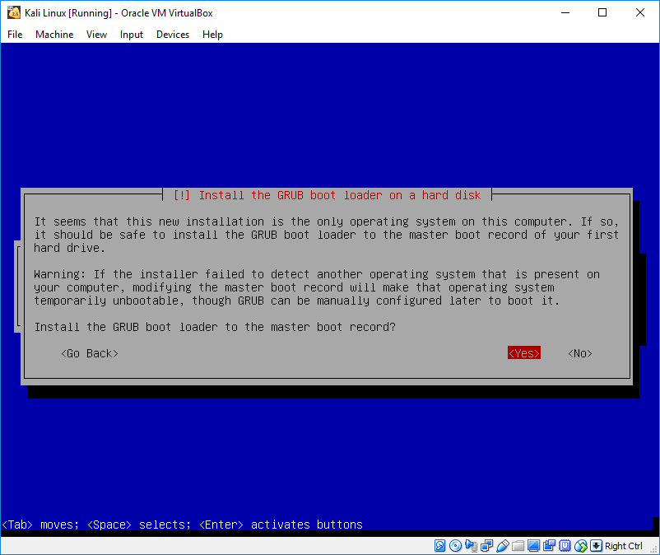

Select the only device you have, normally /dev/sda
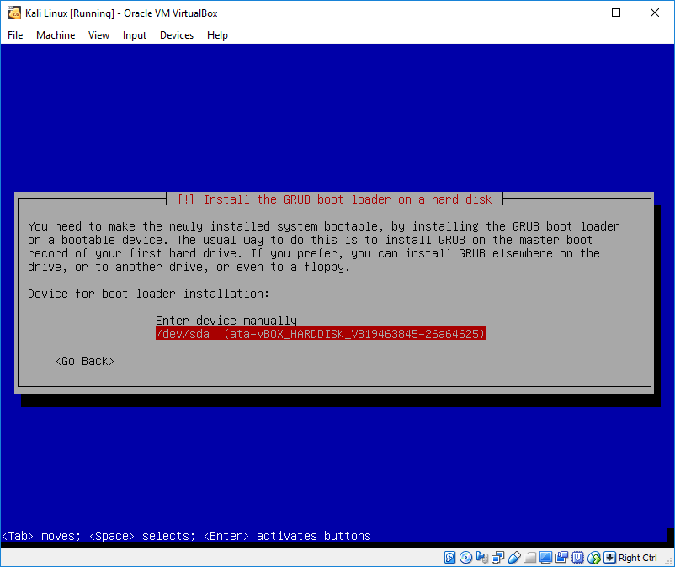
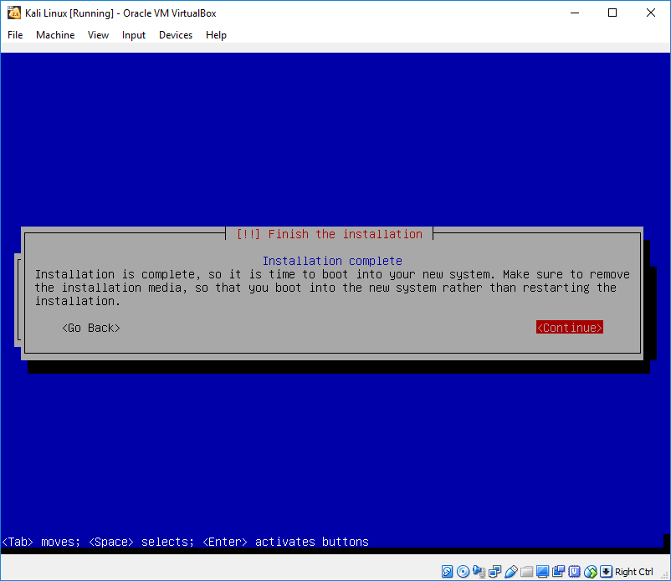

Uncheck this box ‘Live CD/DVD’
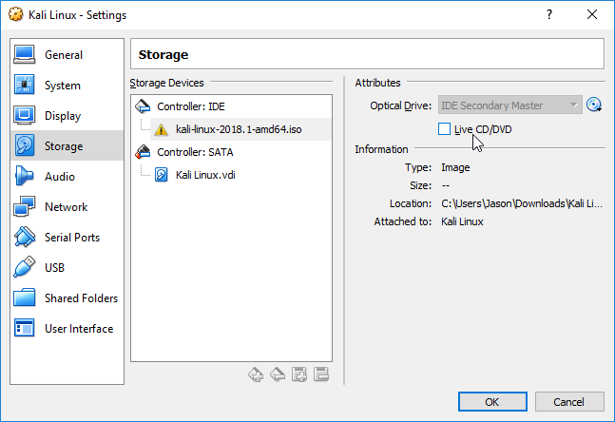
Login with the credentials you setup, above I used
User: root
Pass: toor
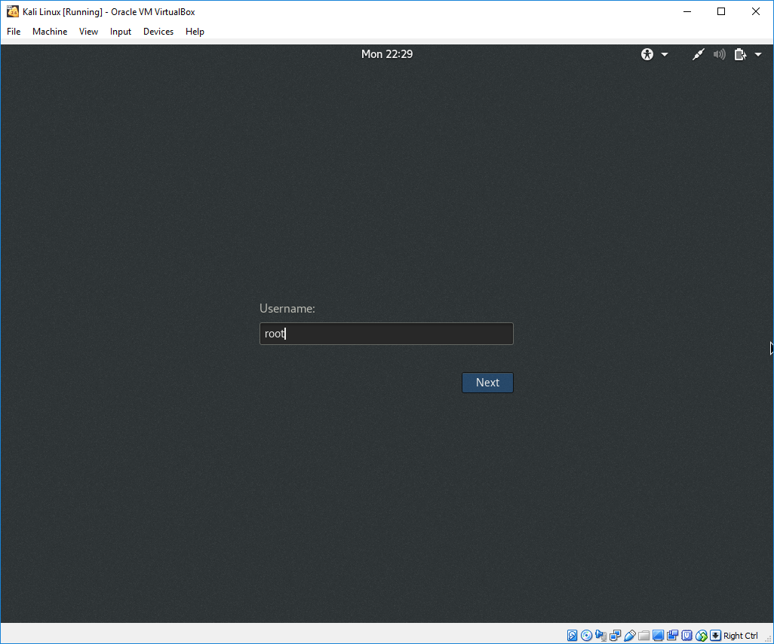

Have fun and thanks for participating in the Great Computer Challenge, 2018!

